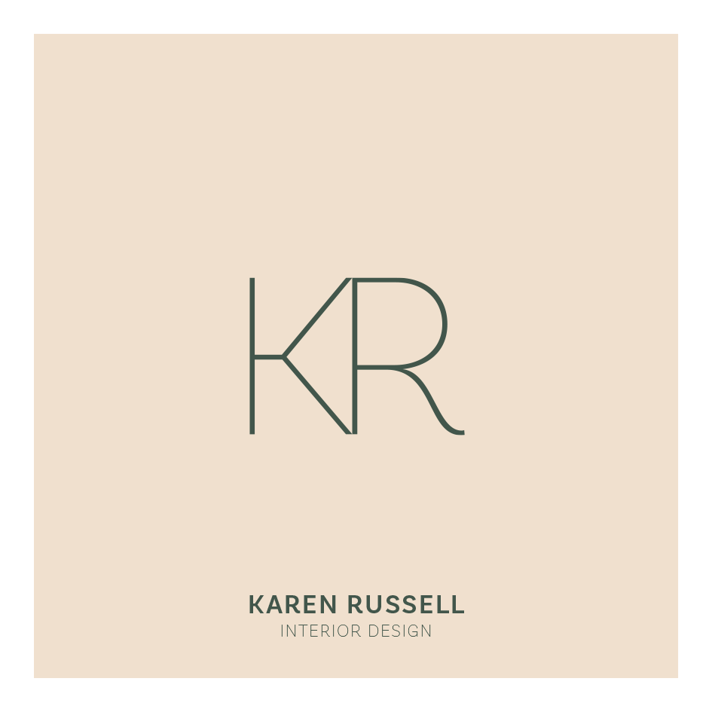

Privacy Policy

Who we are
Our website address is: https://www.karenrussellinteriordesign.co.uk/
What personal data do we collect, and why do we collect it
Comments
We do not accept comments on our site.
Media
We do not accept media being uploaded to our site.

Contact forms
Our contact forms are used solely and exclusively to provide contact by email for enquiry purposes.

Cookies
If you have an account and log in to this site, we will set a temporary cookie to determine if your browser accepts cookies. This cookie contains no personal data and is discarded when you close your browser.
When you log in, we will set up several cookies to save your login information and screen display choices. Login cookies last two days, and screen options cookies last a year. If you select “Remember Me”, your login will persist for two weeks. If you log out of your account, the login cookies will be removed.

Embedded content from other websites
Articles on this site may include embedded content (e.g., videos, images, articles, etc.). Embedded content from other websites behaves exactly as if the visitor has visited the other website.
These websites may collect data about you, use cookies, embed additional third-party tracking, and monitor your interaction with that embedded content, including tracking your interaction with the embedded content if you have an account and are logged in to that website.

Who do we share your data with
Karen Russell Interior Design does not share data with any third parties.

